Course Title: Hydration

Grade Level: 6th - 8th grade

Description:
In this course you will explore the role hydration plays in maintaining overall health and athletic performance. You will learn how the body uses water, recognize the signs of dehydration, and develop healthy hydration habits.
*Verify/Update Standards*
Missouri:
FS1G7
FS1I7
Arkansas:
Nutrition: Students will apply concepts of how food choices impact the overall health of self and
others, and investigate how different types of eating disorders damage body systems.

Course Image:
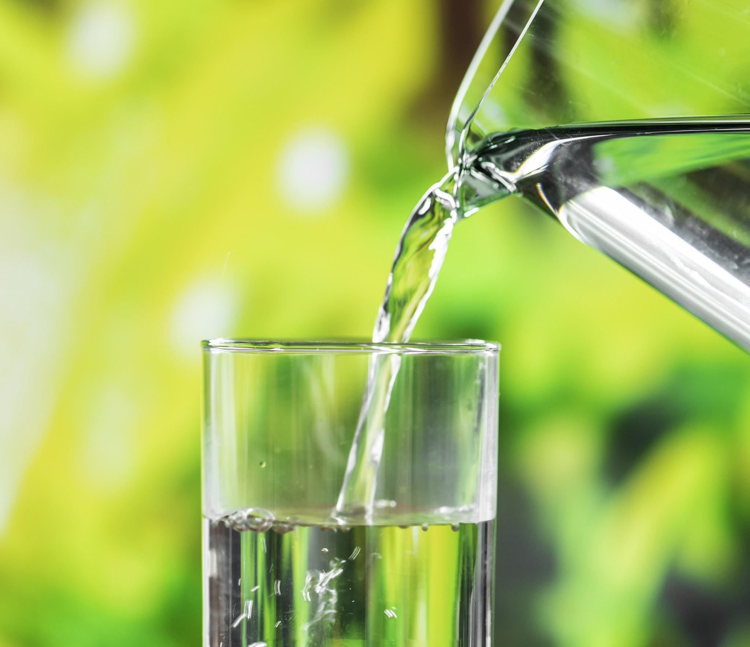
Video URL:
Get Healthy: Hydration | NBC News Learn

